Responsible Pet Ownership
Animal Control Bylaw No. 1 of 2024
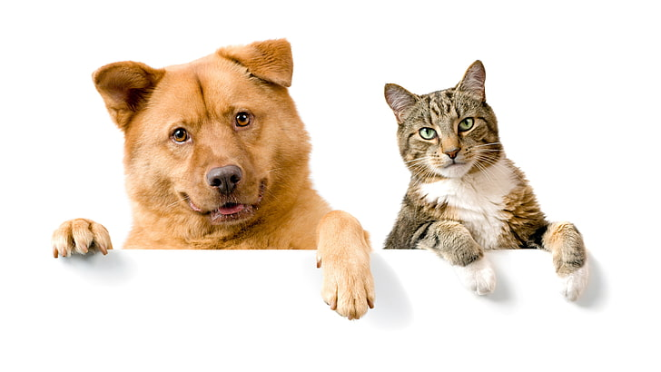
There are a number of regulations that provide for safe and healthy environment for people and their pets.
Fine vary depending on the nature of the violation:
- Failure to license a dog/cat or failure to attach a valid license when off your property (licenses are none transferable)
1st Offense $150.00
- Dog/Cat being at large
1st Offense
- Dog/cat feces must be removed immediately from public or private property (other than the owner’s property)
1st Offense
- Dogs/cats must not chase, threaten or injury people or other animals
1st Offense
- Exceeding the maximum number of animals 3 dog and 3 cats on any one property
1st Offense
- Dog/cat barking or howling
1st Offense
To report any of the above violations, contact the Town of Birch Hills (306) 749-2232 during business hours (8:30 a.m. - 4:00 p.m., Monday - Friday). After hour calls may not be answered immediately, but you can leave a voicemail and someone will contact you as soon as possible.
FOR MORE INFORMATION:
This brochure should not be solely relied upon as an official interpretation of the various regulations in effect. For a complete copy of this bylaw, please visit our website: http//www.birchhills.ca

